Design Assignment 4: Fixed Point Numbers, Real Time Response, and Interrupts



Alexis Adie and Madison Mastroberte

ELC 411-01: Embedded Systems

Submitted:

November 9th 2017

Design Assignment 4: Fixed Point Numbers, Real Time Response, and Interrupts

Alexis Adie and Madison Mastroberte

Department of Electrical and Computer Engineering

The College of New Jersey

2000 Pennington Road, Ewing, NJ 08618, USA

(adiea1, mastrom7)@tcnj.edu

# Introduction

The purpose of this experiment was to implement software that could quickly react to changing inputs. Two tasks with their own timing requirements were required to be carried out by the students to display the challenges in managing more than on task. The second part of the experiment had the group use an interrupt service routine (ISR) to carry out the multiple events with the desire to learn more about the benefits of their implementation.

# II. Results

*A. Real Time Response and Waveforms*

**Table 1.** Latency range for a 10 Hz wave frequency with various animation rates without interrupts.

|  |  |
| --- | --- |
| Animation Rate | Estimated Latency |
| 20 ms | 21.5 ms |
| 40 ms | 37.5 ms |
| 60 ms | 82.2 ms |

**Table 2.** Latency range for various animation rates with interrupts.

|  |  |
| --- | --- |
| Frequency | Latency |
| 10 Hz | 0.0 ms |
| 100 Hz | 0.0 ms |
| 100 kHz | 11.3 ms |
| 110 kHz | 12.8 ms |
| 150 kHz | 15.5 ms |

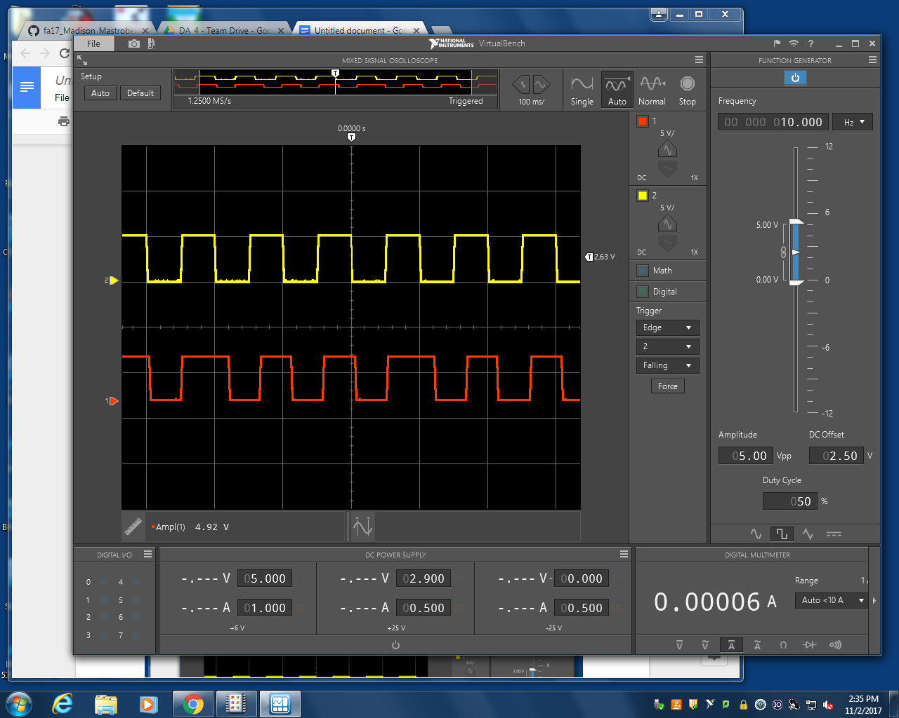

**Figure 1.** Input (yellow) and output (red) square waveforms at 10 Hz with an animation delay of 20 ms [100 ms/div | 5V/div].

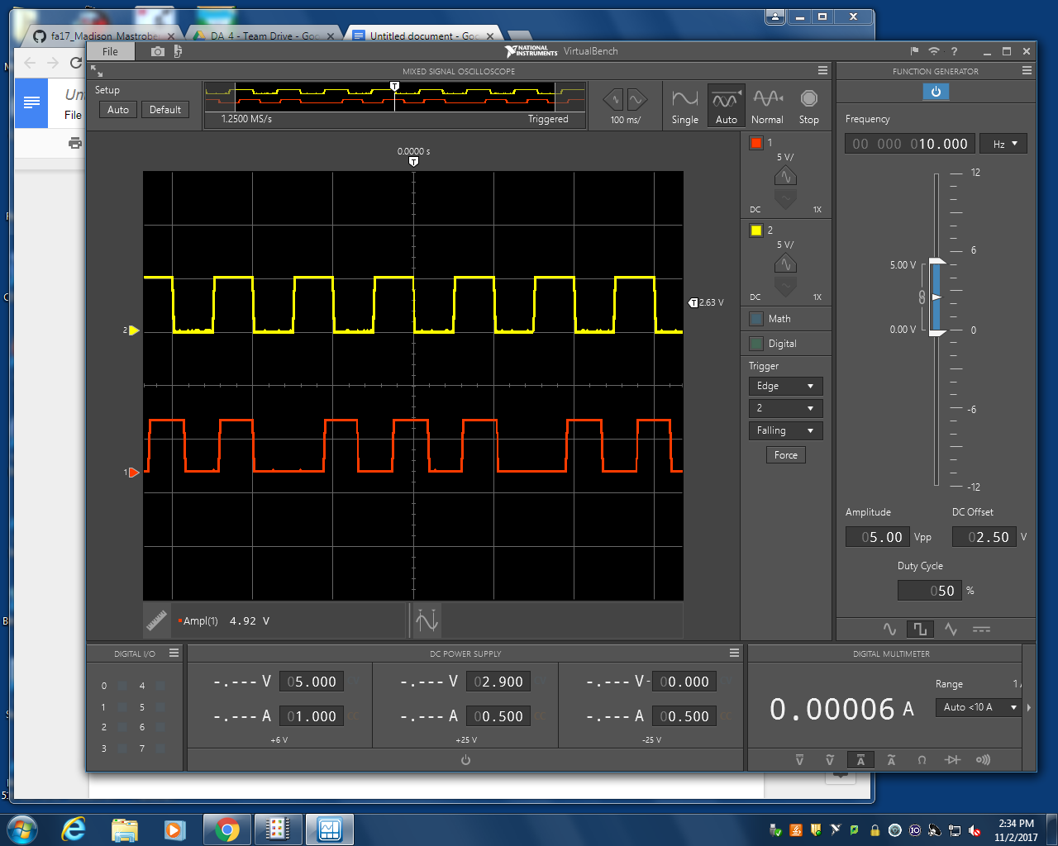

**Figure 2.** Input (yellow) and output (red) square waveforms at 10 Hz with an animation delay of 40 ms [100 ms/div | 5V/div].

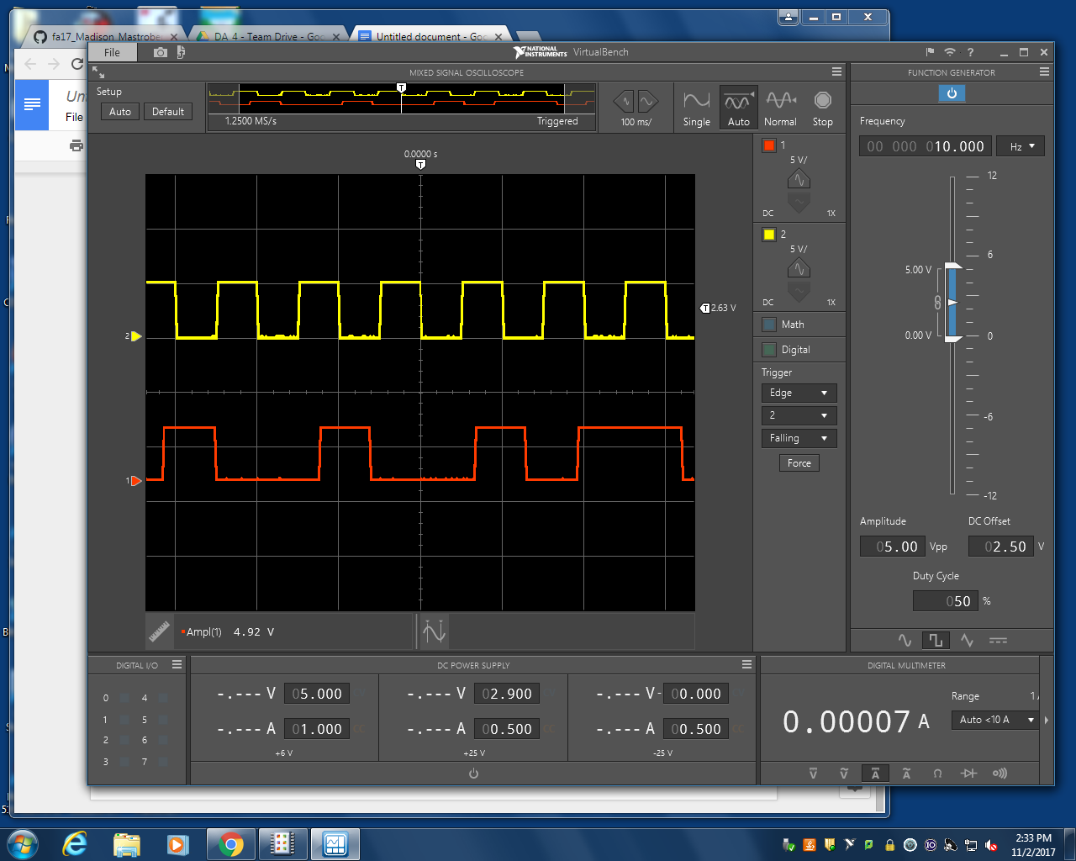

**Figure 3.** Input (yellow) and output (red) square waveforms at 10 Hz with an animation delay of 60 ms [100 ms/div | 5V/div].

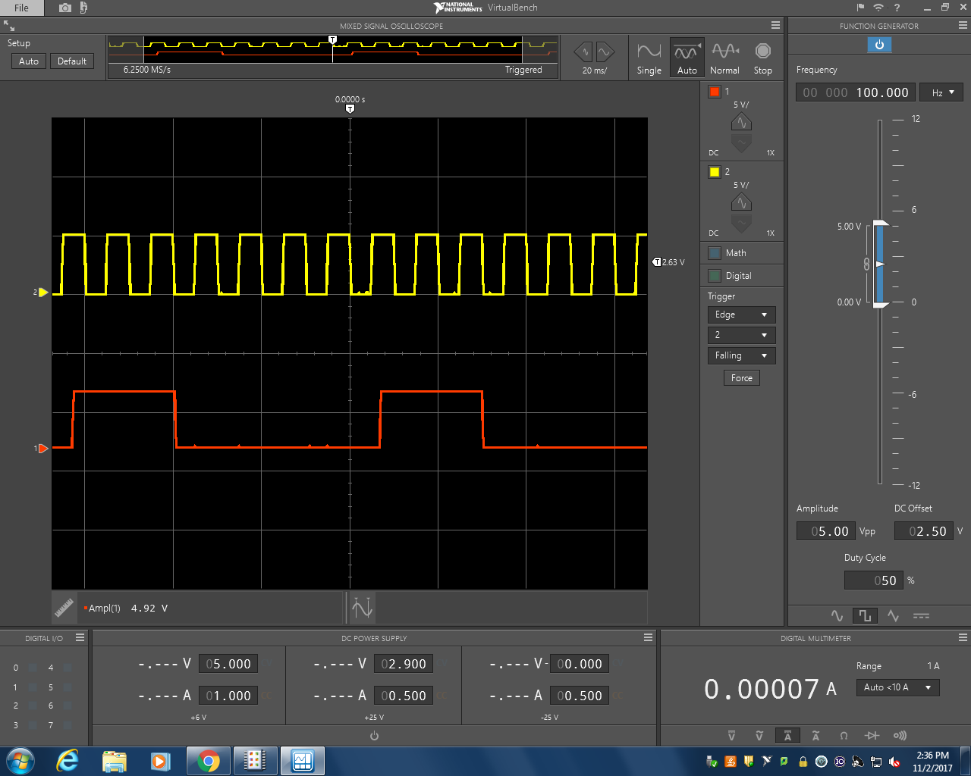

**Figure 4.** Input (yellow) and output (red) square waveforms at 100 Hz with an animation delay of 20 ms [20 ms/div | 5V/div].

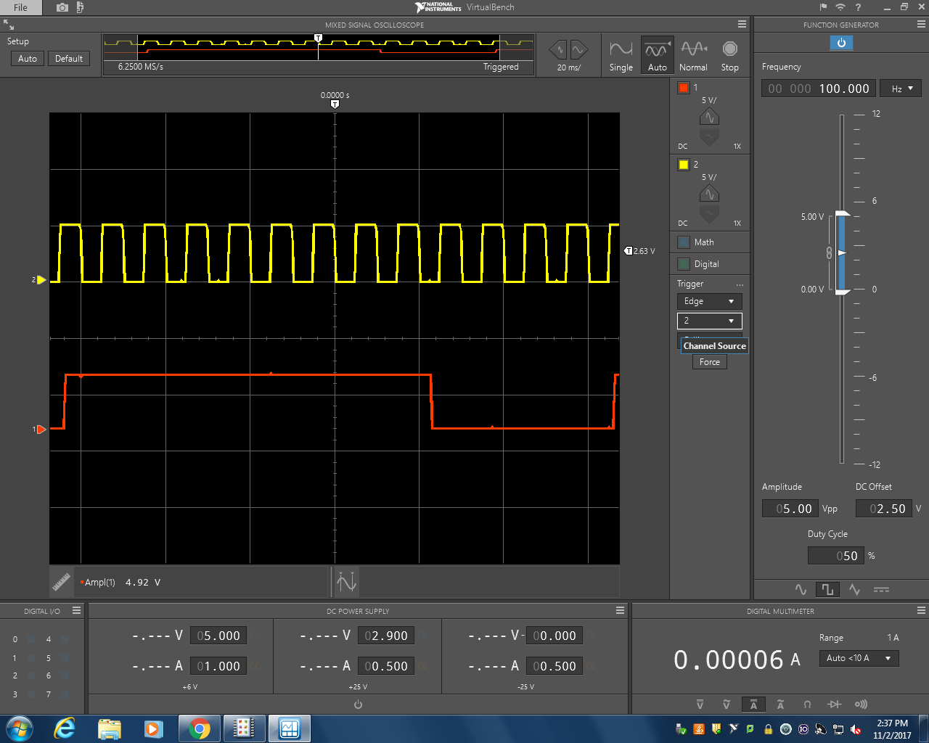

**Figure 5.** Input (yellow) and output (red) square waveforms at 100 Hz with an animation delay of 40 ms [20 ms/div | 5V/div].

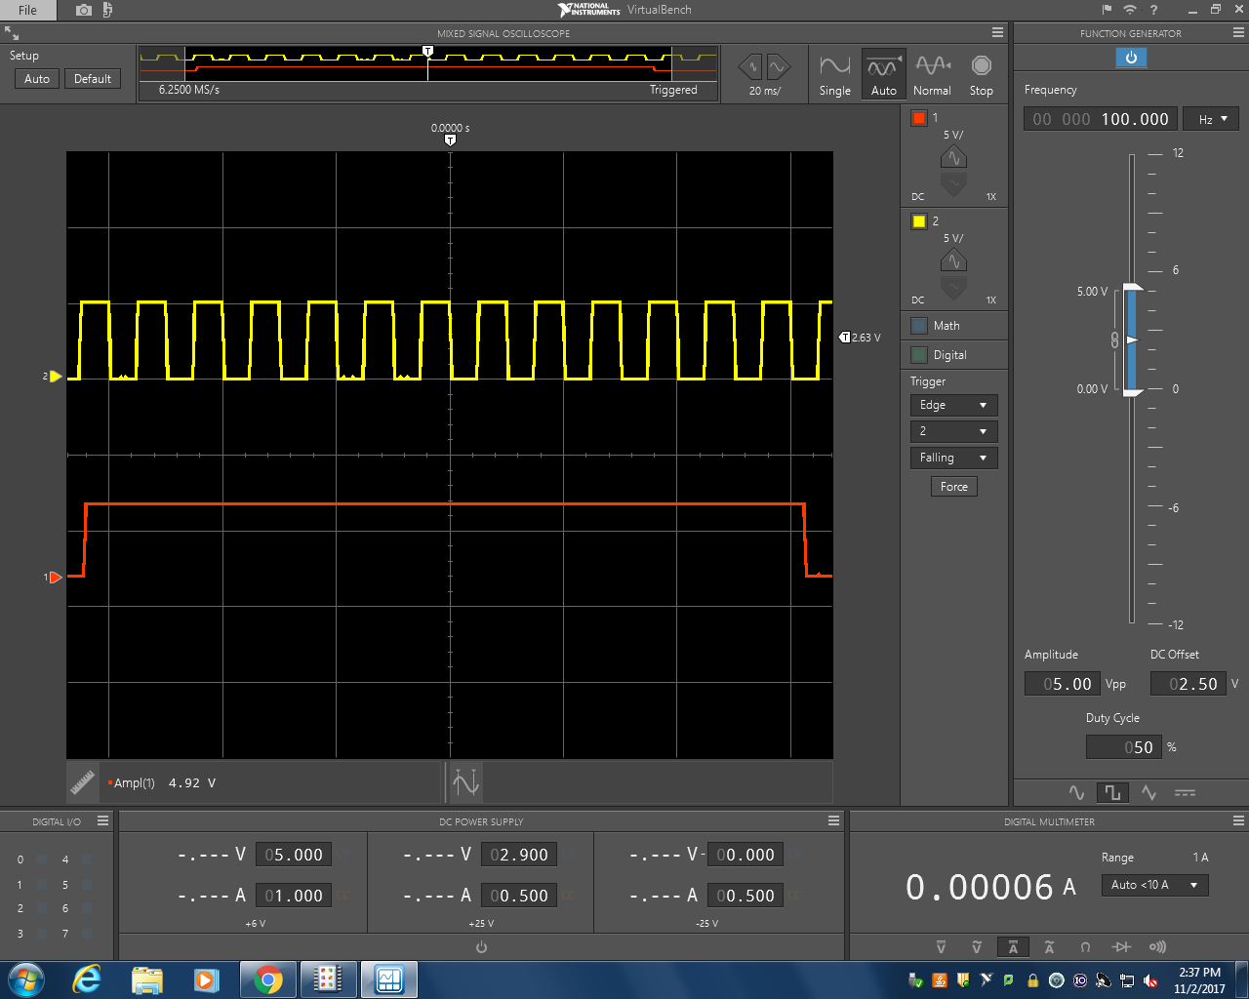

**Figure 6.** Input (yellow) and output (red) square waveforms at 100 Hz with an animation delay of 60 ms [20 ms/div | 5V/div].

*B. Interrupts*

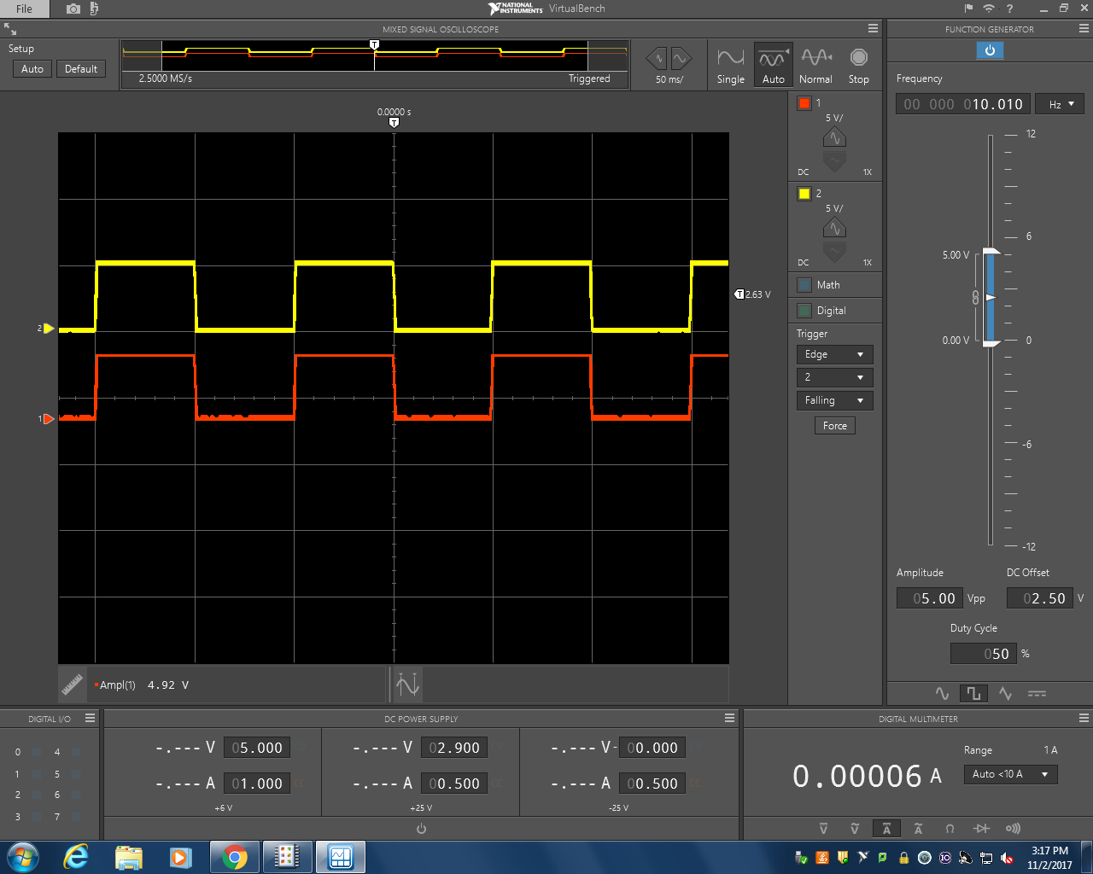

**Figure 7.** Input (yellow) and output (red) square waveforms at 10 Hz with interrupts [50 ms/div | 5V/div].

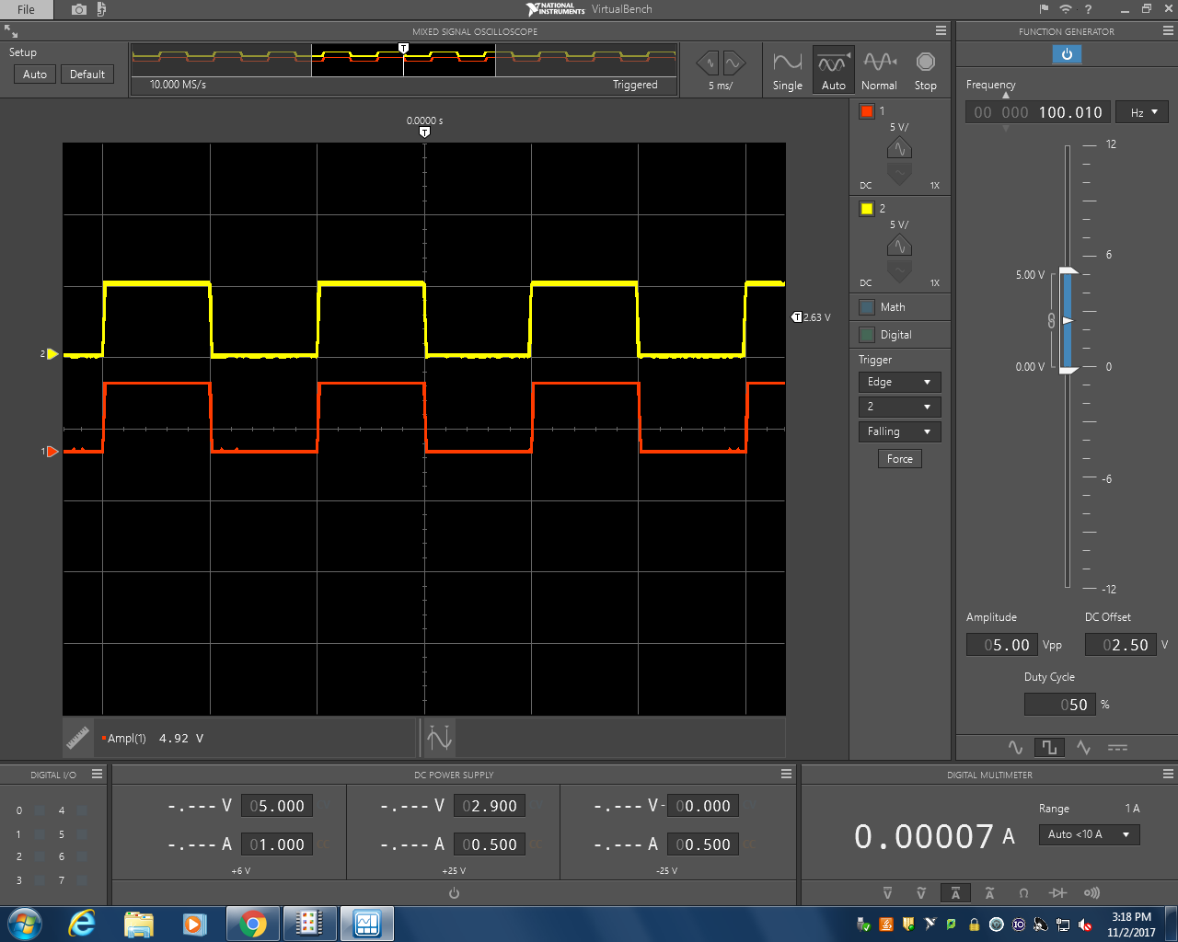

**Figure 8.** Input (yellow) and output (red) square waveforms at 100 Hz with interrupts [50 ms/div | 5V/div].

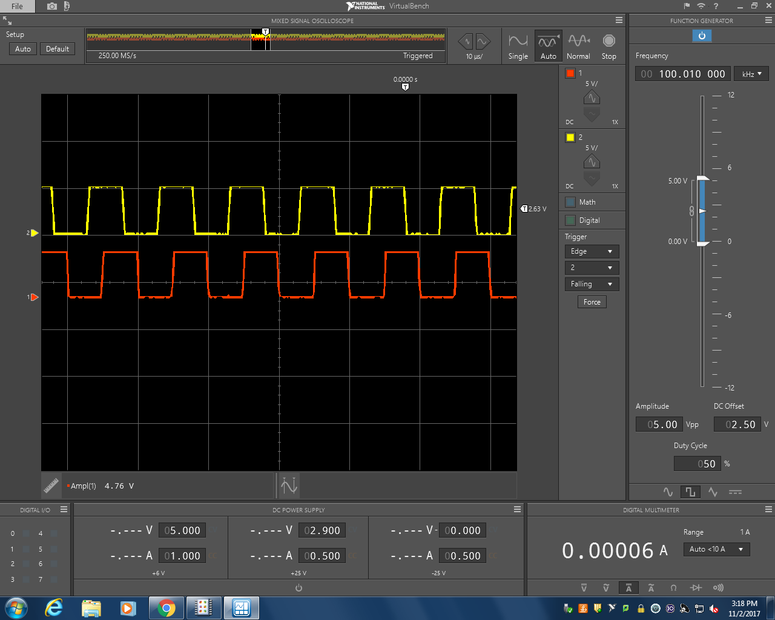

**Figure 9.** Input (yellow) and output (red) square waveforms at 100 kHz with interrupts [50 ms/div | 5V/div].

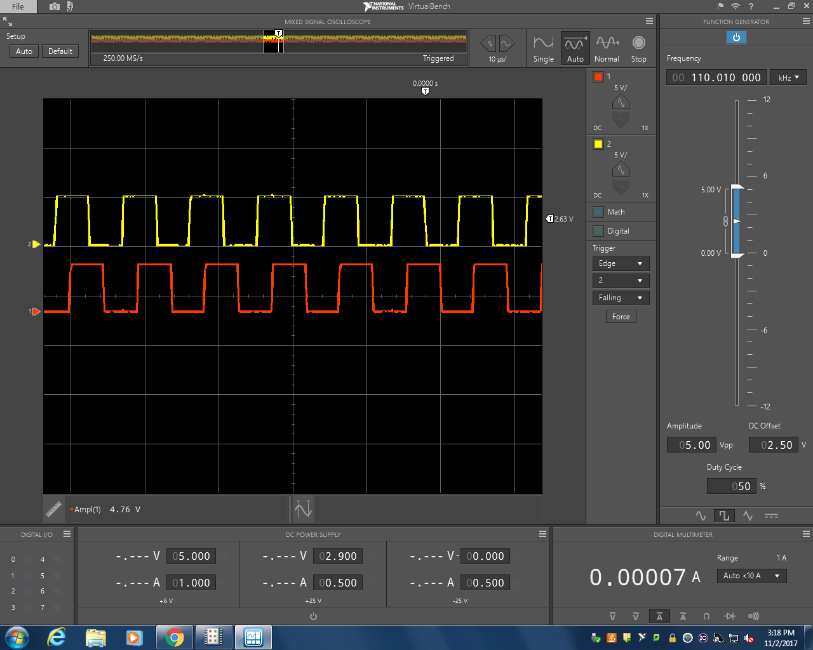

**Figure 10.** Input (yellow) and output (red) square waveforms at 110 kHz with interrupts [50 ms/div | 5V/div].

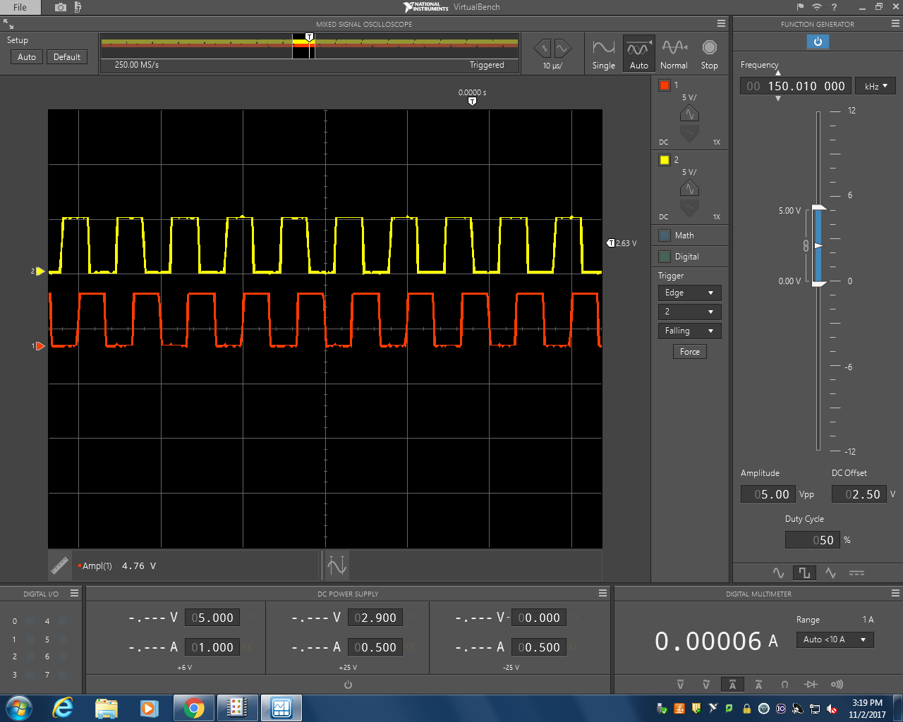

**Figure 11.** Input (yellow) and output (red) square waveforms at 150 kHz with interrupts [50 ms/div | 5V/div].

# III. Discussion

i. Animation Failure

In part two, the animation failed at any frequency over 150kHz. This failure was due to limitations in the hardware. The program was going through too many iterations for the board to update.

1. System Response without Interrupts

The system response in part 1 was as expected. As the delay on the LCD screen got larger, the output represented by DIG_OUT_PIN received a greater delay. However, the actual latency measured was never completely accurate with the error ranging from 7.5-37%. The error seemed to increase as the delay was increased.

1. System Response with Interrupts

The system response with interrupts showed the benefit of including them in a design. At the initial frequencies the latencies recorded were zero. As the frequency was increased, however, there were latencies present. These findings can be explained by the CyDelay function.

1. CyDelay Function Failure

As the program went through more iterations, the CyDelay function began to “steal”cycles from the isr, causing latencies at higher frequencies.

1. Timing Diagram

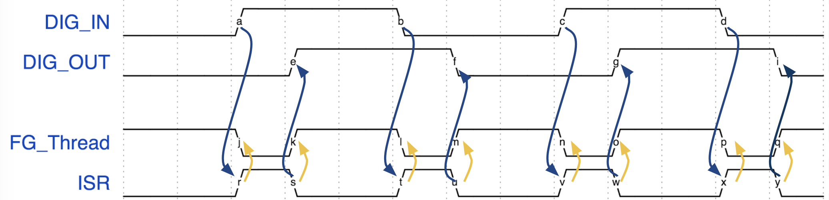

**Figure 12.** Timing diagram for ISR and foreground service routines, with dependencies.

# IV. CONCLUSION

The purpose of this experiment was to introduce students to the use of interrupts as well as fixed-point integers in order to better implement a program design. The latency expected while a computer completes two or more tasks was reduced greatly with the implementation of an interrupt. By learning this concept, the team will be able to produce more efficient code in the future.

# VI. Appendix

**Madison Mastroberte’s Code**

#include <project.h>

#include <stdio.h>

// Unsigned Fixed Point Macros, UQm.n

#define FIX_n (16) // fixed point 'n' value

#define FIX_m (16) // fixed point 'm' value

#define FIX_N (FIX_n + FIX_m) // total bits in Qm.n

#define FIX_FACTOR (1 << FIX_n ) // fixed point fraction factor (2^n)

#define FIX__0_5 (1 << (FIX_n-1)) // 0.5 expressed in UQ16.16

#define FIX__1_0 (1 << FIX_n ) // 1.0 expressed in UQ16.16

// Procedure:

// fix2int - round a fixed point value to the nearest integer

// Inputs:

// fix - fixed point value to round

// Return value:

// result of rounding the fixed point value to nearst integer, in uint32_t container

uint32_t fix2int( uint32_t fix )

{

//Adds 0.5 in fixed point and discards the 16 fractional bits to zero

fix = (fix + FIX__0_5)>> 16 ;

return fix;

}

// Procedure:

// fix2double - Convert a fixed point value to double precision

// Inputs:

// fix - value to convert

// Return value:

// double precision representation of fixed point value

double fix2double( uint32_t fix )

{

//Adds 0.5 in fixed point and discards the 32 fractional bits to zero

fix = (fix + FIX__0_5) >> 16;

return fix;

}

// Procedure:

// double2fix - Convert a double precision value to fixed point, with rounding

// Inputs:

// x - value to convert

// Return value:

// fixed point approximation of the input value, in uint32_t container

uint32_t double2fix( double x )

{

//Adding 0.5 in floating point

x = (x + 0.5);

//Rounding fractional bits

//Casting explicitly

int y = (int)x;

y = y >> 16;

return y;

}

// Procedure:

// fix2decimalstr - convert fixed point value to decimal string

// Inputs:

// x - fixed point value to convert to string

// str - pointer to destination string

// dotn - desired decimal precision

void fix2decimalstr( uint32_t x, char *str, int dotn )

{

int i;

uint64_t lx;

int len;

// Use 64 bit int to avoid overflow

lx = x;

// Multiply by 10^dotn, to shift all fractional decimal into integer part

for (i = 0; i < dotn; ++i)

{

lx *= 10;

}

// Get the integer part via rounding by adding half, and right shifting n

lx += FIX__0_5;

lx >>= FIX_n;

x = (uint32_t) lx;

// Print the number, but without decimal point

sprintf( str, "%d", (int) x );

len = strlen(str);

// Insert the decimal point in the correct location

// First move all of the last 'dotn' characters to the right to make space

str[len+1] = '\0';

for (i = 0; i < dotn; ++i)

{

str[len-i] = str[len-i-1];

}

str[len-dotn] = '.';

}

int main()

{

int k; // Current position of bouncing box (relative to LCD)

int direction; // +1 --> move right, -1 --> move left

char num_str[17]; // Array to render the value of rate as a string

char msg_str[17]; // Entire message, to write to LCD

int sw2; // Holds current switch state

int sw3; // Holds current switch state

int sw2_prev; // Holds previous state, for button down detection

int sw3_prev; // Holds previous state, for button down detection

CyGlobalIntEnable; /* Enable global interrupts. */

uint32_t delay = 20 * FIX__1_0; // UQ16.16

uint32_t llim = 20 * FIX__1_0; // Upper limit of delay expressed in UQ16.16

uint32_t ulim = 200 * FIX__1_0; // Upper limit of delay expressed in UQ16.16

uint32_t incr = double2fix( 10.0/3.0 ); // Represent 3.33... in fixed point

LCD_Display_Start(); // Start the LCD component

k = 0; // Initialize position

direction = 1; // and direction

sw2 = sw3 = sw2_prev = sw3_prev = 1; // Initialize switch states to open

// Loop forever

for(;;)

{

// Convert current delay to a string, with 3 decimal places precision

fix2decimalstr(delay, num_str, 3);

// Generate composite message string

sprintf( msg_str, "Delay=%7s ms", num_str );

// Render current state onto the display

// Top line is bouncing square

// Bottom line is current delay

LCD_Display_ClearDisplay(); // Must clear entire display before new rendering

LCD_Display_DrawHorizontalBG(0, k, 1, 5); // Draw the box on top line

LCD_Display_Position(1, 0); // Position on bottom line

LCD_Display_PrintString(msg_str); // Print the msg on bottom line

DIG_IN_PIN_Read() ;

DIG_OUT_PIN_Write(DIG_IN_PIN_Read()) ;

CyDelay(fix2int(delay)); // Delay based on integer part of delay

k += direction; // Compute new position

if (k == 15)

direction = -1;

else if (k == 0)

direction = 1;

sw2 = SW2_Read(); // Get current switch state

sw3 = SW3_Read(); // Get current switch state

if (sw2 == 0 && sw2_prev == 1) // If Switch 2 button down event, decrease delay

delay -= incr;

if (sw3 == 0 && sw3_prev == 1) // If Switch 3 button down event, increase delay

delay += incr;

sw2_prev = sw2; // Update previous sw2 state

sw3_prev = sw3; // Update previous sw3 state

// Saturate delay to upper and lower limits

if (delay > ulim) delay = ulim;

if (delay < llim) delay = llim;

}

}

**Alexis Adie’s Code**

include <project.h>  
#include <stdio.h>  
  
// Unsigned Fixed Point Macros, UQm.n  
#define FIX_n (16) // fixed point 'n' value  
#define FIX_m (16) // fixed point 'm' value  
#define FIX_N (FIX_n + FIX_m) // total bits in Qm.n  
#define FIX_FACTOR (1 << FIX_n ) // fixed point fraction factor (2^n)  
#define FIX__0_5 (1 << (FIX_n-1)) // 0.5 expressed in UQ16.16  
#define FIX__1_0 (1 << FIX_n ) // 1.0 expressed in UQ16.16  
  
// Procedure:  
// fix2int - round a fixed point value to the nearest integer  
// Inputs:  
// fix - fixed point value to round  
// Return value:  
// result of rounding the fixed point value to nearst integer, in uint32_t container  
uint32_t fix2int( uint32_t fix )  
{  
 //n bits  
 float bitn= 10.0*n;  
 fix =(int) (fix*bitn+0.5)/bitn;  
   
 //fix= (int) (fix*100+0.5)/100.0;  
   
 //the variable F would receive the value 2.468, not the rounded value of 2.47 which would   
 //be appropriate for most monetary uses. To assign the rounded result of 2.47 into variable R, we would use the expression  
  
 // R = (int) (F*100+0.5) / 100.0;  
  
 // which would offset the decimal point two places by multiplying F by 100 (resulting in 246.8),   
 //then bump the value to 247.3, and then truncate the .3 portion by casting the value into integer   
 //form, and finally reposition the decimal point by dividing the result be 100.0. It is essential to w  
 //rite the value 100 in floating point notation (with the .0 attached) to prevent C from performing integer   
 //division which would corrupt the results.  
 //round(uint32_t fix);  
  
}  
  
// Procedure:  
// fix2double - Convert a fixed point value to double precision   
// Inputs:  
// fix - value to convert  
// Return value:  
// double precision representation of fixed point value  
double fix2double( uint32_t fix )  
{  
  
 fix= (int) (fix+0.5);  
   
}  
  
// Procedure:  
// double2fix - Convert a double precision value to fixed point, with rounding  
// Inputs:  
// x - value to convert  
// Return value:  
// fixed point approximation of the input value, in uint32_t container  
uint32_t double2fix( double x )  
{  
 x= (int) (x+0.5);  
}  
  
// Procedure:  
// fix2decimalstr - convert fixed point value to decimal string  
// Inputs:  
// x - fixed point value to convert to string  
// str - pointer to destination string  
// dotn - desired decimal precision  
void fix2decimalstr( uint32_t x, char *str, int dotn )  
{  
 int i;  
 uint64_t lx;  
 int len;  
   
 // Use 64 bit int to avoid overflow  
 lx = x;  
   
 // Multiply by 10^dotn, to shift all fractional decimal into integer part  
 for (i = 0; i < dotn; ++i)  
 {  
 lx *= 10;  
 }  
 // Get the integer part via rounding by adding half, and right shifting n  
 lx += FIX__0_5;  
 lx >>= FIX_n;  
   
 x = (uint32_t) lx;  
   
 // Print the number, but without decimal point  
 sprintf( str, "%d", (int) x );  
 len = strlen(str);  
   
 // Insert the decimal point in the correct location  
 // First move all of the last 'dotn' characters to the right to make space  
 str[len+1] = '\0';  
 for (i = 0; i < dotn; ++i)  
 {  
 str[len-i] = str[len-i-1];  
 }  
 str[len-dotn] = '.';  
}  
  
int main()  
{  
 int k; // Current position of bouncing box (relative to LCD)  
 int direction; // +1 --> move right, -1 --> move left  
 char num_str[17]; // Array to render the value of rate as a string  
 char msg_str[17]; // Entire message, to write to LCD  
   
 int sw2; // Holds current switch state  
 int sw3; // Holds current switch state  
 int sw2_prev; // Holds previous state, for button down detection  
 int sw3_prev; // Holds previous state, for button down detection  
   
 CyGlobalIntEnable; /* Enable global interrupts. */  
  
 uint32_t delay = 20 * FIX__1_0; // UQ16.16  
 uint32_t llim = 20 * FIX__1_0; // Upper limit of delay expressed in UQ16.16  
 uint32_t ulim = 200 * FIX__1_0; // Upper limit of delay expressed in UQ16.16  
  
 uint32_t incr = double2fix( 10.0/3.0 ); // Represent 3.33... in fixed point  
   
 LCD_Display_Start(); // Start the LCD component  
   
 k = 0; // Initialize position  
 direction = 1; // and direction  
   
 sw2 = sw3 = sw2_prev = sw3_prev = 1; // Initialize switch states to open  
   
 // Loop forever  
 for(;;)  
 {  
 // Convert current delay to a string, with 3 decimal places precision  
 fix2decimalstr(delay, num_str, 3);  
   
 // Generate composite message string  
 sprintf( msg_str, "Delay=%7s ms", num_str );  
  
 // Render current state onto the display  
 // Top line is bouncing square  
 // Bottom line is current delay  
 LCD_Display_ClearDisplay(); // Must clear entire display before new rendering  
 LCD_Display_DrawHorizontalBG(0, k, 1, 5); // Draw the box on top line  
 LCD_Display_Position(1, 0); // Position on bottom line  
 LCD_Display_PrintString(msg_str); // Print the msg on bottom line  
  
   
   
DIG_IN_PIN_Read() ;  
DIG_OUT_PIN_Write(DIG_IN_PIN) ;  
  
   
 CyDelay(fix2int(delay)); // Delay based on integer part of delay  
 k += direction; // Compute new position  
 if (k == 15)  
 direction = -1;  
 else if (k == 0)  
 direction = 1;  
  
 sw2 = SW2_Read(); // Get current switch state  
 sw3 = SW3_Read(); // Get current switch state  
   
 if (sw2 == 0 && sw2_prev == 1) // If Switch 2 button down event, decrease delay  
 delay -= incr;  
 if (sw3 == 0 && sw3_prev == 1) // If Switch 3 button down event, increase delay  
 delay += incr;  
 sw2_prev = sw2; // Update previous sw2 state  
 sw3_prev = sw3; // Update previous sw3 state  
  
 // Saturate delay to upper and lower limits  
 if (delay > ulim) delay = ulim;  
 if (delay < llim) delay = llim;  
 }  
}

**Commented and Debugged Code**

#include <project.h>

#include <stdio.h>

// Unsigned Fixed Point Macros, UQm.n

#define FIX_n (16) // fixed point 'n' value

#define FIX_m (16) // fixed point 'm' value

#define FIX_N (FIX_n + FIX_m) // total bits in Qm.n

#define FIX_FACTOR (1 << FIX_n ) // fixed point fraction factor (2^n)

#define FIX__0_5 (1 << (FIX_n-1)) // 0.5 expressed in UQ16.16

#define FIX__1_0 (1 << FIX_n ) // 1.0 expressed in UQ16.16

extern uint32 volatile int_count;

// Procedure:

// fix2int - round a fixed point value to the nearest integer

// Inputs:

// fix - fixed point value to round

// Return value:

// result of rounding the fixed point value to nearst integer, in uint32_t container

uint32_t fix2int( uint32_t fix )

{

//Adds 0.5 in fixed point and discards the 16 fractional bits to zero

return (fix +FIX__0_5) >> FIX_n;

}

// Procedure:

// fix2double - Convert a fixed point value to double precision

// Inputs:

// fix - value to convert

// Return value:

// double precision representation of fixed point value

double fix2double( uint32_t fix )

{

//Adds 0.5 in fixed point and discards the 32 fractional bits to zero

fix = (fix + FIX__0_5) >> 16;

return fix;

}

// Procedure:

// double2fix - Convert a double precision value to fixed point, with rounding

// Inputs:

// x - value to convert

// Return value:

// fixed point approximation of the input value, in uint32_t container

uint32_t double2fix( double x )

{

return (uint32_t) (x * FIX_FACTOR + 0.5);

}

// Procedure:

// fix2decimalstr - convert fixed point value to decimal string

// Inputs:

// x - fixed point value to convert to string

// str - pointer to destination string

// dotn - desired decimal precision

void fix2decimalstr( uint32_t x, char *str, int dotn )

{

int i;

uint64_t lx;

int len;

// Use 64 bit int to avoid overflow

lx = x;

// Multiply by 10^dotn, to shift all fractional decimal into integer part

for (i = 0; i < dotn; ++i)

{

lx *= 10;

}

// Get the integer part via rounding by adding half, and right shifting n

lx += FIX__0_5;

lx >>= FIX_n;

x = (uint32_t) lx;

// Print the number, but without decimal point

sprintf( str, "%d", (int) x );

len = strlen(str);

// Insert the decimal point in the correct location

// First move all of the last 'dotn' characters to the right to make space

str[len+1] = '\0';

for (i = 0; i < dotn; ++i)

{

str[len-i] = str[len-i-1];

}

str[len-dotn] = '.';

}

int main()

{

isr_1_Start();

int k; // Current position of bouncing box (relative to LCD)

int direction; // +1 --> move right, -1 --> move left

char num_str[17]; // Array to render the value of rate as a string

char msg_str[17]; // Entire message, to write to LCD

int sw2; // Holds current switch state

int sw3; // Holds current switch state

int sw2_prev; // Holds previous state, for button down detection

int sw3_prev; // Holds previous state, for button down detection

CyGlobalIntEnable; /* Enable global interrupts. */

uint32_t delay = 20 * FIX__1_0; // UQ16.16

uint32_t llim = 20 * FIX__1_0; // Upper limit of delay expressed in UQ16.16

uint32_t ulim = 200 * FIX__1_0; // Upper limit of delay expressed in UQ16.16

uint32_t incr = double2fix( 10.0/3.0 ); // Represent 3.33... in fixed point

LCD_Display_Start(); // Start the LCD component

k = 0; // Initialize position

direction = 1; // and direction

sw2 = sw3 = sw2_prev = sw3_prev = 1; // Initialize switch states to open

// Loop forever

for(;;)

{

// Convert current delay to a string, with 3 decimal places precision

fix2decimalstr(delay, num_str, 3);

// Generate composite message string

// sprintf( msg_str, "Delay=%7s ms", num_str );

sprintf(msg_str,"Cnt=%12lu",int_count );

// Render current state onto the display

// Top line is bouncing square

// Bottom line is current delay

LCD_Display_ClearDisplay(); // Must clear entire display before new rendering

LCD_Display_DrawHorizontalBG(0, k, 1, 5); // Draw the box on top line

LCD_Display_Position(1, 0); // Position on bottom line

LCD_Display_PrintString(msg_str); // Print the msg on bottom line

// *****************************************************************************************

//DIG_IN_PIN_Read() ;

// DIG_OUT_PIN_Write(DIG_IN_PIN_Read()) ;

// *****************************************************************************************

CyDelay(fix2int(delay)); // Delay based on integer part of delay

k += direction; // Compute new position

if (k == 15)

direction = -1;

else if (k == 0)

direction = 1;

sw2 = SW2_Read(); // Get current switch state

sw3 = SW3_Read(); // Get current switch state

if (sw2 == 0 && sw2_prev == 1) // If Switch 2 button down event, decrease delay

delay -= incr;

if (sw3 == 0 && sw3_prev == 1) // If Switch 3 button down event, increase delay

delay += incr;

sw2_prev = sw2; // Update previous sw2 state

sw3_prev = sw3; // Update previous sw3 state

// Saturate delay to upper and lower limits

if (delay > ulim) delay = ulim;

if (delay < llim) delay = llim;

}

}